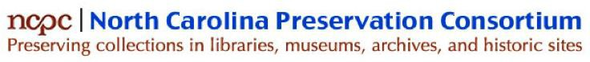
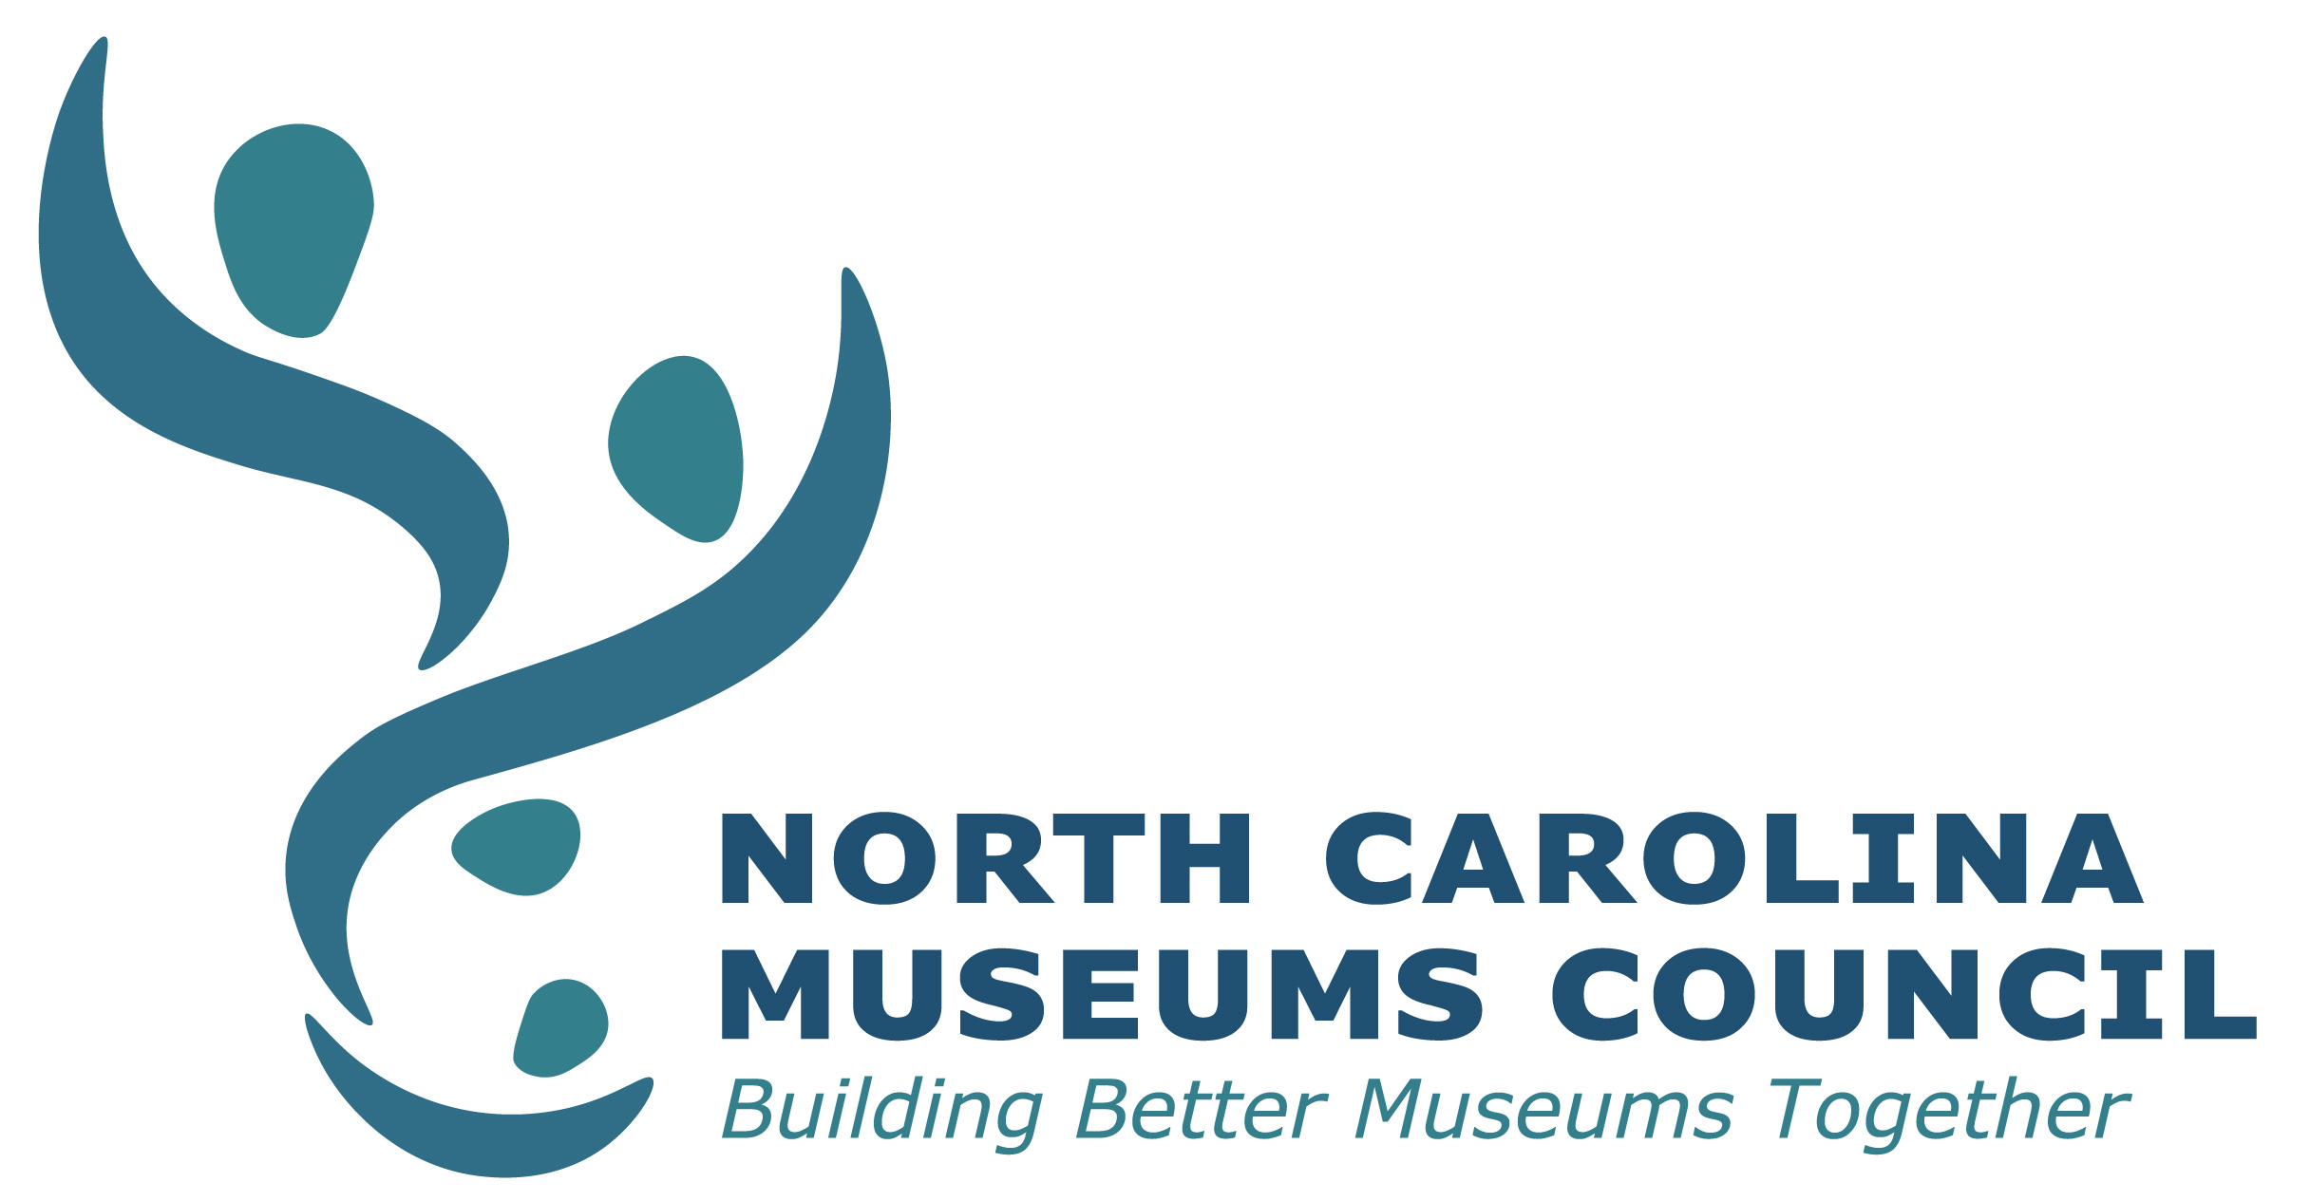

Disaster Relief Grant Application

Purpose and Scope of Grant: To provide funds for collection preservation assistance for institutions affected by Federal and State of North Carolina declared natural disaster events. Applications citing global pandemics will not be accepted. Please fill out the entire application form including attaching any required documents.
- For electronic submissions - attachments may be in the form of an electronic document, an active URL to the requested documentation.
- For paper submissions – include all attachments with your paper submission.

Missing information including but not limited to unanswered questions, inactive URL’s, or incomplete answers may cause the application to be considered incomplete. Only complete applications will be reviewed. The Grants Committee is under no obligation to contact the applicant for missing information.
Applicants must be an NCPC or NCMC institutional member in good standing. Membership information can be found at https://ncpreservation.org/join or https://ncmc.wildapricot.org/join-us/ . Please see the Disaster Relief Grant website for a full eligibility checklist.

Title of Grant Project:
Total Grant Request (max. $1,000): $

Legal Name of Institution:
Employer Identification Number (EIN):

Address:

City, State, Zip Code:

Name:
Position Title:

Phone Number:
Email Address:

INSTITUTIONAL INFORMATION

Is your institution a member of NCPC or NCMC?
- Yes
- No

- Type of institution (choose all that apply):
- Archives
- Historic Site
- Library
- Museum
- Other (please describe):

- Institution’s total annual budget this year: $

- Annual budget for preservation or collections management: $

Does your institution have a position responsible for preservation or collections management?
- No
- Yes (if yes, please give us the following information): Name:
Title:

Phone Number:
Email address:
Percentage of their time devoted to preservation or collections management activities:

Provide a link to your organization’s website. If you have a mission and/or vision statements, please also provide a direct link to those.

Main URL:
Mission/Vision statement URL:

Does your institution have a preservation or collections management policy/statement?
- Yes
- No

Does your institution have a written disaster plan?
- Yes
- No

Does your institution have staff trained to implement the disaster plan?
- Yes
- No

Has your institution ever had a preservation or conservation assessment?
- No
- Yes (if yes, please provide the following information) Date of assessment:
Name(s) and position title(s) of the staff involved:
Names of consultant(s) and their affiliated institution(s):
Briefly summarize the assessment and outcomes:

Has your institution ever received a grant from NCPC or NCMC?
- No
- Yes
- Has your institution applied for or received any other disaster relief funding or received insurance reimbursement for disaster damages?
☐ No
☐ Yes (if yes, please explain):

COLLECTION INFORMATION
- Describe the collection that is the focus of this grant proposal.

Are there any claims of ownership or protests of your institution’s ownership, exhibition, or use of this collection?
- No
- Yes (if yes, please explain):

PROJECT INFORMATION

- Damage Description
Please describe the damage that occurred to your institution/collection. Please also attach documentation of the damage (this can be photos, insurance filings, etc.).

- Project Description
Please describe the damage that occurred to your collection and describe how the grant will help recover from the disaster, include your goals for this recovery project, activities to be conducted, and the personnel that will support the project.
- Project Timeline
Please provide the timeline for the scope of work described above (a bulleted list is fine).

- Project Staff.
Below please list the institutional representatives that will work on this project. Include name, title, address, telephone number, and email address.

Project Director (individually overseeing the project activities):
Project Treasurer/Financial Officer (individual who will manage and oversee grant funds):
Other Key Personnel (please list their names and roles):

- Project Budget.

Grant money must be spent on eligible expenses including supplies, materials, or conservation treatment directly related to disaster recovery. No portion of a grant may be used for any indirect costs (overhead, facilities, administration, etc.) of the collection institution or the parent organization.

Complete the budget table below showing estimates for all grant expenses. The budget should list the total cost for each item. Include a breakdown of the cost in the description column (as relevant include quantity, unit cost, shipping/handling charges, etc).

Expense | Amount | Description
Supplies & Materials
Conservation Treatment
Total Request | $

I certify that, to the best of my knowledge, all information on this application and the supporting materials is accurate and true.

Name and Title

Signature and date [insert electronic signature, or print and sign document]

Please send completed application form and all required documents:

Email Submissions
Send to ncpcboard@gmail.com application and attachments must be in PDF or current Microsoft Word format.
Paper forms accepted via U.S. Mail:
NCPC/NCMC Disaster Relief Grant Program
North Carolina Preservation Consortium
P.O. Box 2651
Durham, NC 27715-2651

